Boschert Model QUATTRO 1500
CNC Punching Machine with
Fully Automatic Sheet Loading & Unloading System

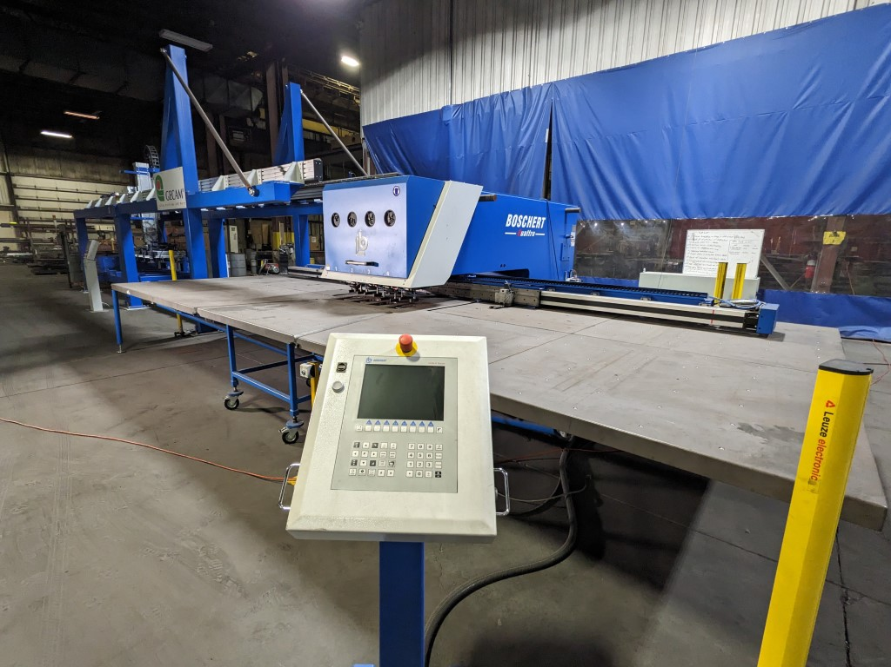

Main Features

- Four Punching Heads, 36 tons each, Trumpf Style Tooling
- 5’ x 10’ sheet size
- Fully automatic loading and unloading of 5’ x 10’ x up to ½” thick sheets

Boschert Model QUATTRO 1500
CNC Punching Machine with
Fully Automatic Sheet Loading & Unloading System

Working range without repositioning 60” x 120”
Maximum punching force 36 Tons
Type of tooling used Trumpf
Maximum punch diameter 4.1” or any shape within
Maximum material thickness – standard clamps (Option: 0.500”) 0.250”
Maximum weight of sheet in clamps 880 lbs.
Maximum stroke length (Programmable) 0 - 3.54”
Maximum strokes per minute 400 spm
Positioning accuracy +/- 0.002”
Positioning repeatability +/-0.001”
Positioning speed (adjustable)
X – Axis Maximum 2,350 ipm
Y – Axis Maximum 1,100 ipm
Tool change time, Manual 15 seconds

Included optional equipment:
- Extra heavy-duty X-axis for 400kg sheet capacity
- Trumpf locking die holders for each station
- High speed hydraulics with oil chiller
- Vacuum slug removal
- Automatic tool lubrication
- Extra clamps
- Ball supports in the table

Pneumatic loading system
- Heavy duty design
- Fully integrated with the punching machine
- Capacity to load 450kg sheets

Current Cost to replace $595,000.00
Warranty: Full one-year parts and labor warranty against defects in material or workmanship.
Delivery: Available immediately

PRICE, On location in Illinois, USA $355,000.00
Cost to prepare for loading $5,000.00

Boschert Model QUATTRO 1500

Control Features:
- CNC software: Boschert graphic programming
- Control display: TFT 10.4” color display
- Control Features:
- 50 part program storage capacity in control memory
- Extended storage device with capacity of
approximately 100,000 programs (256mB) on hard drive and the included SD card. In addition, there is a USB port at the operator pendant.
- Includes LAN connection easily integrated to your computer network.
- Automatic stroke and part counter
- Automatic “clamp find” function
- Automatic referencing upon start-up
- Both axes move simultaneously with programmed priority for either axis
- Tooling list capacity of 500 tools with graphic support
- Automatic punch power control
- Canned cycles including single hole, row of holes, hole circle, mirror image
- Notching (up to 3 steps)
- Rectangles • Mirror image • Zoom
- Remove waste • Sub-programs • Bolt-hole circle
- Nibble circle • Matrix of holes • Ellipse
- “V” belt shapes • Contour program (Rotation station only)
- Piece counter • Engraving

OTHER FEATURES:
Pneumatic material clamps, Safety light barriers around machine, automatic repositioning,

GENERAL SPECIFICATIONS:
Height of table above floor 35”
Approximate floor space required 26.5’LR x 21.5’FB x 83”High
Hydraulic oil reservoir capacity 42 gallons
Electric motor for hydraulic system 15 HP
Approximate weight of machine 35,000 lbs.
Color RAL 5017 Blue
Connected voltage 480/3/60

